**Problem Statement:-**

* In the hostel environment, the operational efficiency of laundry collection often faces challenges due to the manual process of physically knocking on each dormitory door. This traditional method leads to inconsistent results, as students may inadvertently miss the notification, causing delays in laundry submission and subsequent inconvenience. Such delays can cascade, disrupting the entire laundry cycle and exacerbating the situation over multiple days.

**Proposed Solution:-**

* To mitigate these challenges, a technologically advanced alert system is proposed. This system aims to revolutionize the laundry collection process by introducing a synchronized notification mechanism for hostel students. The key component of this solution is the implementation of a floor-wide alert system triggered by the arrival of laundry personnel. This system utilizes a combination of hardware and software components to ensure timely and reliable notifications to all occupants.

**System Overview:-**

* The laundry alarm system is designed with a robust architecture to seamlessly integrate with the existing infrastructure of the hostel. At its core, the system comprises NodeMCU modules strategically deployed on each floor, serving as the communication hubs. These modules facilitate real-time communication with ATMega32 microcontrollers installed in individual dormitory rooms.
* The communication protocol leverages a combination of Wi-Fi for inter-device connectivity, I2C (Inter-Integrated Circuit) for intra-floor communication, and SPI (Serial Peripheral Interface) for interfacing with peripheral devices. This multi-tiered approach ensures efficient data exchange and enables precise control over the alarm activation process.
* Upon the arrival of laundry personnel, a designated button located on each floor is pressed to activate the alert system. This action triggers the NodeMCU modules to broadcast a signal to all connected ATMega32 microcontrollers within the vicinity. Upon receiving the signal, the microcontroller in each dormitory room activates a buzzer to alert the occupants.
* To provide a user-friendly experience, the buzzer remains active until manually deactivated by the occupants within their respective rooms. This feature ensures that every student receives the notification promptly and can respond accordingly without delay.

**Technical Architecture:**

* **NodeMCU (ESP8266)**: Installed at every floor, the NodeMCU serves as the primary interface for laundry personnel. Upon pressing the designated button, the NodeMCU detects the signal and initiates a Wi-Fi transmission to the ATMega32 units in the respective student rooms.
* **ATMega32 Microcontroller**: Situated in each student room, the ATMega32 processes incoming signals from the NodeMCU and controls the activation of the room's buzzer. It remains in a standby mode until a signal is received, at which point it triggers the alarm.
* **Buzzer Activation**: Upon receiving the enable signal from the NodeMCU, the ATMega32 activates the buzzer within the student's room. The buzzer remains active until the student presses the designated "off" button to silence the alarm.
* **Inter-room Communication - I2C Protocol:** In multi-room settings, adjacent ATMega32 units communicate using the I2C protocol. Once the alarm is triggered in one room, the adjacent ATMega32 units receive the signal and activate the respective room's buzzer, creating a cascading alert mechanism.
* **Inter-floor Communication - SPI Protocol:** For alerting neighboring floors, the system employs the SPI protocol. When the laundry alarm is activated on one floor, the NodeMCU transmits a signal via SPI to neighboring NodeMCU units, thereby alerting personnel on adjacent floors.

**Solution Flow:-**

* Laundry personnel initiate the alarm system by pressing the designated button on the NodeMCU located on the respective floor.
* The NodeMCU detects the button press and establishes a Wi-Fi connection to transmit an enable signal to the ATMega32 unit in the corresponding student room.
* Upon receiving the signal, the ATMega32 activates the buzzer within the room, alerting the student of the laundry personnel's presence.
* The buzzer remains active until the student presses the designated "off" button, silencing the alarm.
* In multi-room settings, adjacent rooms are interconnected via the I2C protocol. When one room's alarm is activated, neighboring rooms receive the signal and activate their respective buzzers.
* Furthermore, the system facilitates inter-floor communication using the SPI protocol. When an alarm is triggered on one floor, neighboring floors are alerted through the transmission of signals between NodeMCU units.
* This comprehensive approach ensures prompt and efficient alerting of students throughout the dormitory, optimizing laundry management processes while minimizing disruptions.
* We added inter-floor communication and inter–room communication to reduce the overall cost of system implementation and to improve the performance of the system.

**Flow Chart :-**

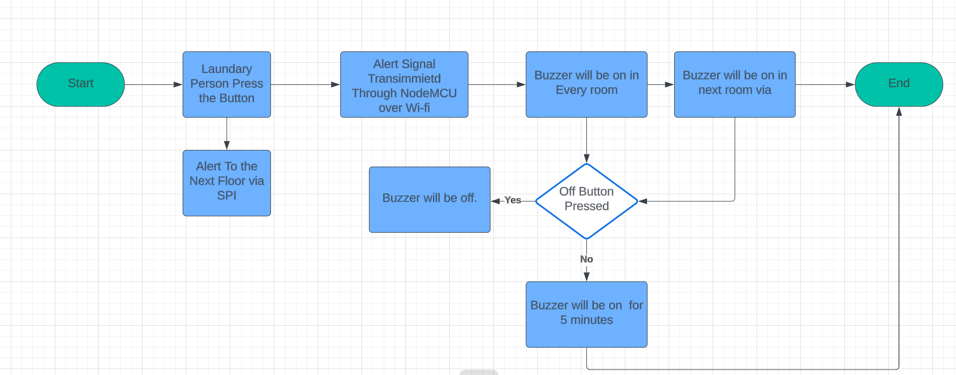

**Block Diagram :-**

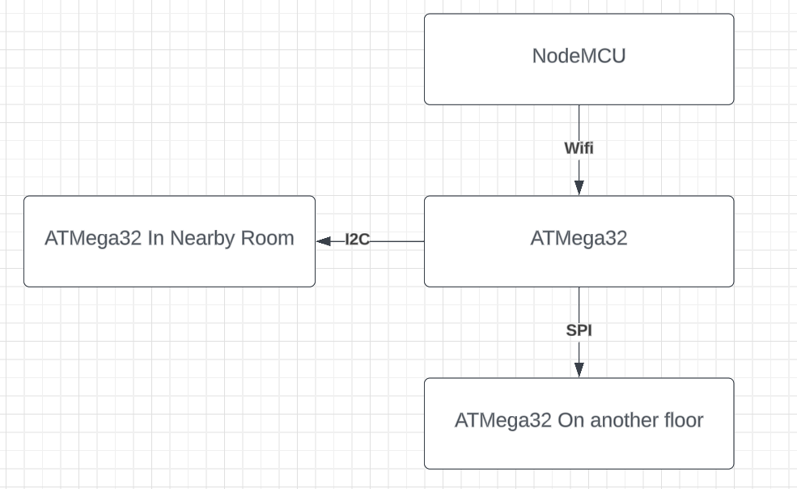

**Pseudo Code :-**

NodeMCU Module:

while True:

if button_pressed():

transmit_signal_over_wifi()

wait_for_response()

ATMega32 Microcontroller:

while True:

if signal_received():

activate_buzzer()

wait_for_off_button_press()

Buzzer Activation:

while True:

if enable_signal_received():

turn_on_buzzer()

wait_for_off_button_press()

Inter-room Communication (I2C Protocol):

while True:

if alarm_triggered():

activate_buzzer()

broadcast_signal_to_adjacent_rooms()

Inter-floor Communication (SPI Protocol):

while True:

if alarm_triggered():

broadcast_signal_to_neighboring_floors()

**Solution Flow:**

1. Laundry personnel initiate the alarm system by pressing the designated button on the NodeMCU module.
2. Upon button press detection, the NodeMCU initiates the alarm activation process by transmitting a Wi-Fi signal.
3. The ATMega32 microcontroller in the corresponding student room receives the Wi-Fi signal and activates the buzzer.
4. The buzzer remains active until manually deactivated by the occupants using the designated "off" button.
5. In multi-room settings, adjacent rooms are interconnected via the I2C protocol. When one room's alarm is activated, neighboring rooms receive the signal and activate their respective buzzers.
6. Furthermore, the system facilitates inter-floor communication using the SPI protocol. When an